F. Programming Control Structures
By Lt Col Tom Schorsch
Introduction
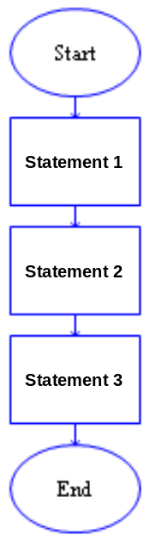
One of the most important parts of programming is controlling which statement will execute next. In this reading, you will learn the statements, called control structures or control statements, that enable you, as a programmer, to determine the order in which your program statements are executed. Using these control structures, you can determine the order that statements are executed, the number of times that statements are executed, and whether or not statements are executed at all.
Sequential Control
So far, controlling which statement is executed next has been incredibly easy. In the programs you have written so far, you controlled which statement is executed next by ordering them one after the other. Essentially you placed each statement in the order that you wanted them to be executed. The first statement of a program that is executed is the first statement after the Start statement. Once that statement is finished executing (i.e. the semantics associated with that statement have been accomplished), then the statement immediately following that statement is executed. Once the second statement is executed, the third is executed, and then the fourth, and so on until the End is reached. As you can see by the inset diagram, the arrows linking the statements depict the execution flow. If you have 20 programming statements in the instruction section, then when your program runs successfully, it will execute those 20 statements in order and then quit.

Sequential Control |  | Used to execute statements, one after the other, in the order in which they appear in the program.

Notice that you, as a programmer, have total control over which statements are executed before others, merely by your placement of those instructions relative to each other in the instruction sequence. It is your job as a programmer to determine the statement that is needed and its placement. Writing the correct statement is one task. Determining where to place that statement is equally important. As an example, when you want to get and process data from the user you have to GET the data before you can use it. Switching the order of these statements means that your program is trying to use data that it hasn’t gotten yet.

Sequential control is “free,” in the sense that you accomplish sequential control just by placing statements in the order you want them to be executed. Now suppose that some of the statements in your program need to be executed repeatedly until some condition is satisfied, or that some of them should only be executed under certain conditions. Based on what you’ve learned so far, you have no way to achieve that kind of control in your program.
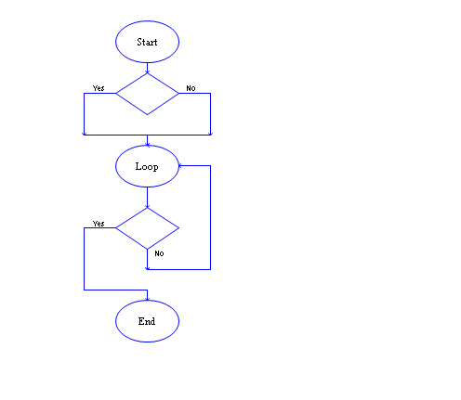

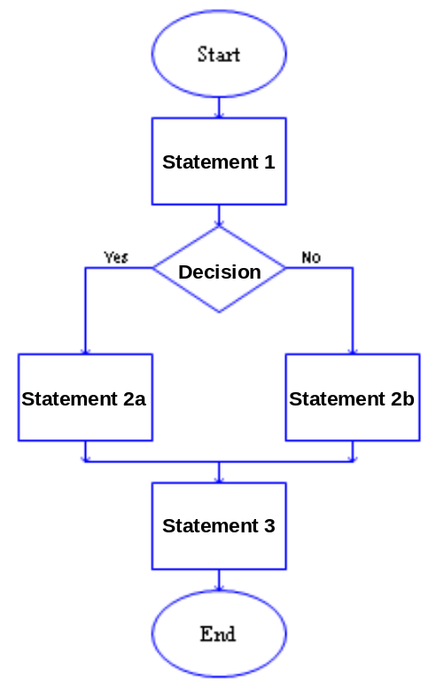
Introduction to Selection Control

The algorithm you are developing may need to do some actions based upon a decision. For example, an algorithm that is evaluating a formula can check to see if a number is negative before taking the square root of that number and then proceed differently depending on whether the result will be a normal number or a complex number. Another example is processing grades. If the grade is above 90%, an A is assigned to the student, between 80% and 90%, a B is assigned to the student, and so on.

A selection-control statement controls whether or not a collection of code is executed or which collection of code is executed. In the inset diagram, the diamond shape represents a decision that when executed could result in an answer of Yes or No (True or False). Depending on what the answer is, the flow of control will follow the appropriate path. In the example, either statement 2a or statement 2b will be executed. One of them will be executed, but not both. However, regardless of which statement 2 was executed, statement 3 will always be executed.

There need not be a statement 2a or a statement 2b. Either path could be empty or could contain several statements. It would be silly for both of them to be empty (or both have the exact same statements), as your decision, Yes or No, would have no effect (nothing different would happen based on the decision).

Selection Control examples
This section presents some concrete uses of selection control statements.

The exact decision you write down affects whether the Yes or No paths are taken. It is very easy to change the decision to switch the yes and no paths. For example, on the left below is a simple decision on whether a student’s GPA makes the grade for being on the Dean’s list. On the right are two different rephrasings of the decision such that the No path is taken if the student is on the Dean’s list. Some people prefer the version on the left and some the version on the top right. Very few prefer the bottom right because of the double negative implicit in the decision.

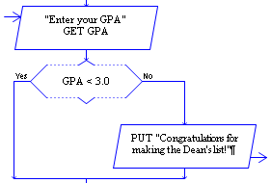
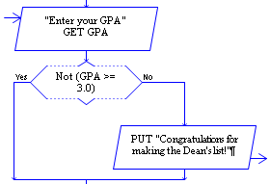
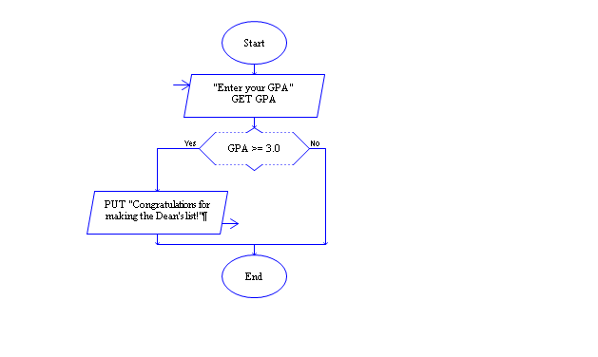

Cascading Selection statements
Sometime you are not making a selection between two alternatives, but making a decision amongst multiple alternatives. If this is the case, you need to have multiple selection statements. For example, if you are assigning a grade (A, B, C, D, or F) you need to select between the multiple choices. The following RAPTOR program includes multiple selection statements. If you follow the control logic, you can see how the selections cascade (as in water cascading over a series of falls).

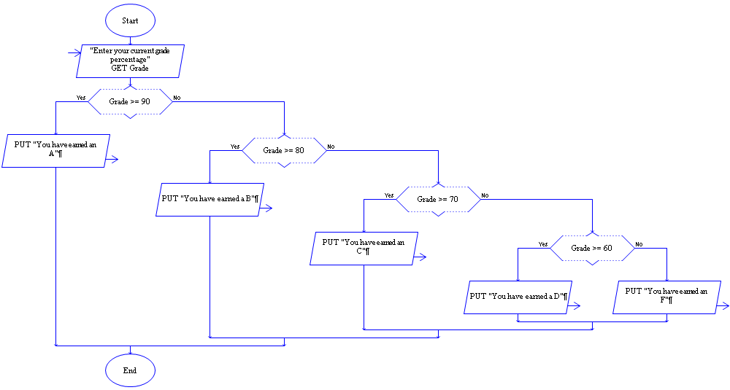

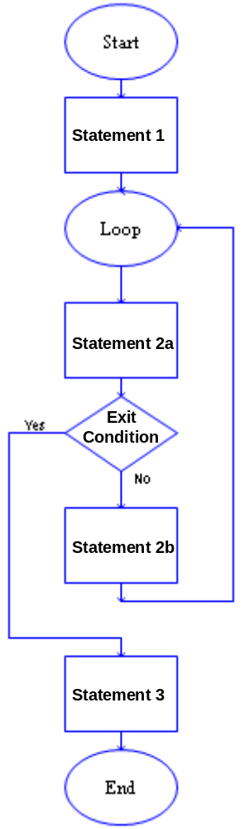
Introduction to Iteration Control

An iteration control statement controls how many times a block of code is executed. Often you need to execute some code until a condition occurs. As you may not know in advance how many times you will need to execute the code, you can’t simply cut and paste the code a specific number of times. Even if you did know how many times the code would repeat, copying it that many times is not a good idea, as any error in your code would be replicated that many times as well.

In the diagram on the right, statement 1 and statement 2a are always executed. If the exit condition is true, then the loop exits and statement 3 is executed. If the exit condition is false the statement 2b and then statement 2a are executed and the exit condition is checked again. As long as the exit condition is false, statement 2b and then statement 2a will be executed again and again.

The exit condition may never be true. We’ll have some examples of that later. You have to have some code, in statement 2a or statement 2b, that makes a change that turns the exit condition to true, without that, if it starts out being false, it will remain false forever.

As with the generic selection example, any of the statements in the example could be replaced by several statements. As with the selection statement, it is possible to nest loop statements. It is also possible to nest selection statements in loop statements and vice versa.
Loop Control examples
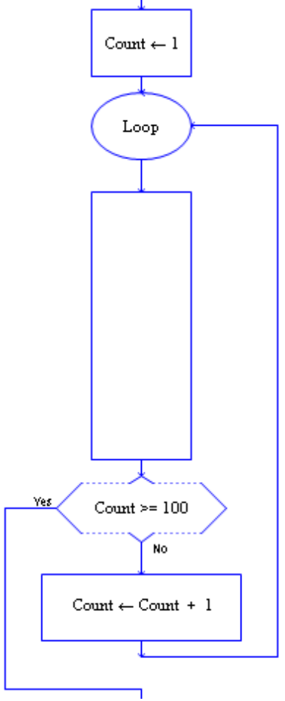
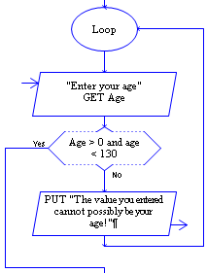
One of the most common uses of a loop is to validate user input. If you want the user to input data that meets certain constraints, such as entering a persons age (see near right example), or a number between 1 and 10, then validating the user input will ensure such constraints are met before processing continues.

As we do not know if, or how many times, the user will attempt to enter data that does not meet the constraints, a loop must be used to ensure that correct data is entered. The exit condition establishes exactly what criteria must be met for the data to be validated.

Another common use of a loop is to execute code a specific number of times. To do this you need to count the number of loop executions and to exit. This type of loop is called a counter-controlled loop. In the example at the right, the long box signifies some sort of processing that must (in this example) be accomplished 100 times. The loop control variable, in this example is Count. There is nothing magical about the variable name Count, we could have used any legal, meaningful name. The important thing is that the loop control variable must be initialized before the loop, modified in the middle of the loop, and tested to see if the loop has executed enough times. If any of these three elements are missing, the loop will not execute the correct number of times.

Some loops are called infinite loops because the exit condition could never be true. The three examples below are slight variations of the counter-controlled loop example. Each of them has a problem which will cause the loop to be infinite. See if you can spot the error in each piece of code below.

Typically one or more variables are used to control whether the iteration construct exits or loops again. The acronym I.T.E.M (Initialize, Test, Execute, and Modify) can be used to check whether the loop and loop control variable(s) are being used correctly. See if you can spot what is wrong (I.T.E. or M.) with each of the code fragments below.
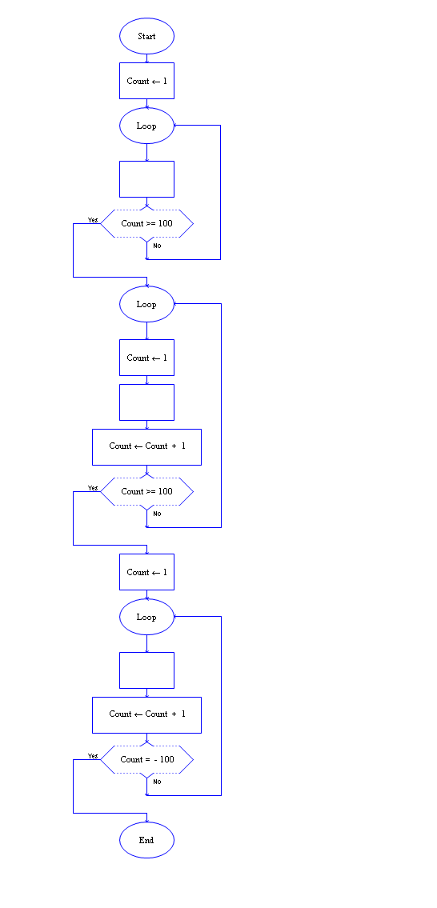

If you can’t spot the error in each of the programs above, compare the programs with the counter-controlled loop example on the previous page.

Sometimes you want users to enter a bunch of values that you can process. There are several ways that this can be accomplished in RAPTOR. The first method is to have the user enter a “special” value that signifies they are finished entering data. A second method is to ask the user in advance how many values that they will be entering and then to use that value to control the loop that asks for the data. These two methods are depicted below. In both cases the empty boxes signify where the entered data should be processed. Don’t worry about how the data is processed, just look at these examples to see how the user controls how much data is entered.

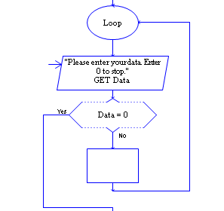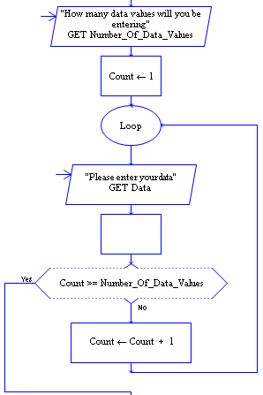
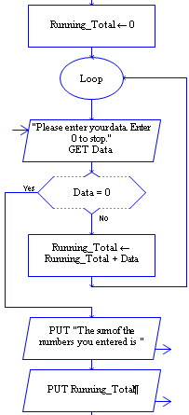
Another common use of loops is to have a running total of the data being processed. For example, the code to the left sums up all of the data values the user enters. You can execute the code by clicking on this link: Loop - Running Total Example.rap.

Notice how similar this example is to the code immediately above it. This example uses the frame work of entering data until a special value (in this case 0) is entered. It then adds several additional statements:
Running_Total ← 0 and
Running_Total ← Running_Total + Data
The first statement must be placed before the loop. It ensures that the variable Running_Total has an initial value of 0. The second statement is the accumulator statement which must be placed inside the loop. Each time the code in the loop is executed an additional Data value is added to the Running_Total variable.

Again, the name Running_Total is not magic. Any variable name could be used. Total or Sum would also be appropriate to use.

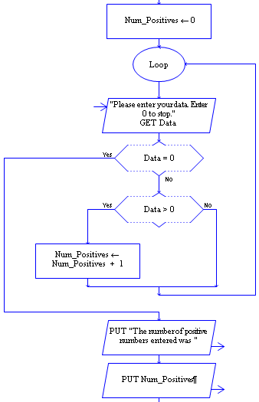

Another common use of loops is for counting the number of times an event occurs.

The example to the right counts the number of positive numbers the user enters. Note that this example also starts with the same base as the previous example and adds several different additional statements:
Num_Positives ← 0 and
Num_Positives ← Num_Positives + 1
The first statement that initializes Num_Positives is before the loop. The second statement is “guarded” by a selection statement. The “guard” ensures you only increment the Num_Positives variable when Data > 0 is true. By replacing the guard test with some other test you can count some other event.

The last two examples demonstrate how the same patterns of code occur over and over again and can be used to solve a variety of similar problems. By studying and understanding the simple examples in this reading you will be able to use these examples as the basis for solving additional, more complex problems.
Combining Iteration and Selection Control (in a More Complex Example)
The next example will be a complete program instead of snippets of code. We want to ask the user to type in a number and then return all of the factors of the number or, if it has none, display that the number is prime. This program is not just a toy exercise, such programs are critical in cryptography as most encryptions are based on the fact that determining the factors of a very large number takes a very long time. In addition, primes are critical in cryptography as you use numbers that only have very large primes as its factors. A program that could quickly determine the factors of a 500-digit number could be used to decode most of the encrypted message traffic in the world today. Unfortunately, while the logic of the program that we write works well for small numbers, it would take millions of years to find the factors for large 500 digit numbers.

One of the goals of CS110 is to teach you how solve problems and program your solutions. Showing you the code would not serve that purpose. Instead, we will describe the process by which the program was developed, and then show you the code. By reading about the process of solving a problem like that above, and then trying it out yourself in the lab, we hope to give you the skills to do it on your own.

A good way to start writing a program is to clearly understand what the inputs to the program are and what outputs the program should produce. It often helps to have several specific examples of this input/output behavior. Often a program can be thought of as a “black box” that changes inputs to outputs. Having several examples helps us understand that “black box” better.

We want our program to exhibit the following behavior. If, for example, the user types in a 77, the program should respond with “7 is a factor of 77.”, and “11 is a factor of 77.”. If the user types in a 41, though, the program should respond “41 is a prime number.” as 41 has no factors.

We can understand the “black box” better by coming up with a process that turns the inputs into outputs and then use that process as the code for your program. Before you can develop a program for a problem you must be able to do the following:
- Solve the problem yourself for particular instances of the problem (like 41 and 77).
- Be able to clearly describe the process by which you arrived at the answer, and have that process be generic enough to be used for any number (not just the two examples).

It is critical that it be a general process. While you may be able to describe exactly how you determined the factors of 77 and that 41 was prime that is not sufficient. You must be able to describe a process that could find all of the factors of any number, and whether any number was prime. If you cannot do so then it will be VERY difficult to write a program to do so!

The following code snippet is a naïve attempt to solve the problem:

if Number = 77 then
PUT "7 is a factor of 77."
PUT "11 is a factor of 77."
else if Number = 41 then
PUT "41 is a prime number."
else if etc.
…

Obviously there are too many different numbers that could be entered by the user for you to code all of them. In addition, if you were to attempt to code a solution to the problem using code like that above, YOU would be doing the grunt work of determining what the factors of a number were and whether it was prime or not, not the computer. The point of using a computer is for it to do all of the tedious work. You, as the programmer, do the work that requires brains. You need to come up with a process and then instruct the computer by writing code that it can use to follow the process and arrive at a solution. Think about how you would describe to anyone, let alone a computer, how to determine all of the factors of a number and whether a number was prime or not… then read on.

One way to determine the factors of a number, X, is to start at the number 2 and then check all of the numbers between 2 and X - 1 to see if any evenly divide X. If none of the numbers in that range evenly divide X then we know X is prime. If any numbers in that range do evenly divide X, then they are factors and we can display them to the user.

The above text describes a process that could be used to determine the factors of any number and if it had none declare the number to be prime. Sometimes just describing a process like that is good enough to start coding from. In this case, because it is the first really complex program you are seeing, we will take the narrative form of the process one step further and create an algorithm, using pseudo code, which makes the steps in the process more like the eventual code.

Prompt for and get a number, storing it as “Possible_Prime”
Assume initially that the number is prime (Set “Is_Prime” to True)
Loop with X ranging from 2 to “Possible_Prime”-1
If a particular X divides “Possible_Prime” evenly then
Display that X is a factor of “Possible_Prime”
Remember that the number is not prime (Set “Is_Prime” to False)
If “Is_Prime” is True then
Display “Possible_Prime” is prime

One of the keys to the above algorithm is the use of the variable “Is_Prime”. First we assume that “Possible_Prime” is a prime number. Then we check all of the numbers, 2 through “Possible_Prime” – 1, one at a time, to determine if any of them divide the “Possible_Prime” number evenly. If any of the numbers are factors then we display the number immediately. However, we also need to “remember” that we now know that “Possible_Prime” is not a prime number. We do that by setting “Is_Prime” to False. Once we have checked all of the numbers in the range we will have displayed all of the factors or there were no factors. In the latter case we can determine that “Possible_Prime” is a prime number because we never “corrected” our original assumption. After the loop is finished we can use the value of “Is_Prime” to determine whether or not to display that “Possible_Prime” is prime.

So far we have accomplished the first two steps of programming. We have understood the problem and better characterized the problem by describing its input/output behavior. We have also designed a solution to the problem that appears to work for all positive integers. The third step is to translate the solution (algorithm) to RAPTOR code. The following code is the translated solution. We have annotated it to make it easier for you to understand. Review the program and make sure you understand how the code relates to the algorithm and the process we came up with for solving the problem.

You can execute the program by clicking here: Complex Example - Factoring a Number.rap.

Annotations to help you understand the factoring program
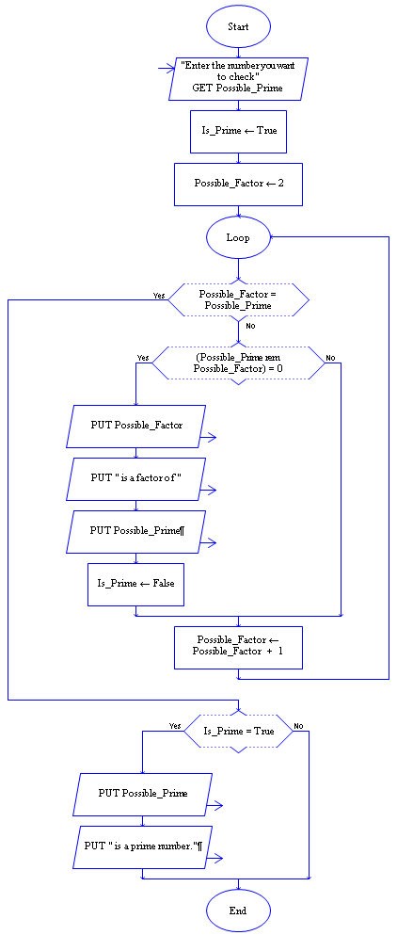
Get the number to check from the user

Assume that the number is prime

Use 2 as the starting point for checking factors

Stop checking possible factors when you count up to “Possible_Prime”

Check if the Possible_Factor evenly Divides the Possible_Prime

If it does evenly divide then the “Possible_Factor” is a real factor

Display all the required text

Set Is_Prime to False indicating that you have found at least one factor

Increment Possible_Factor so you can check if the next number is a factor of the number entered by the user

If Is_Prime is still true, then you didn’t find any factors

If so, display the fact that the user’s number is a prime number.

Successful strategies for using if statements and loops
The following questions are ones your instructor may ask you to help you think about what type of control code you need in your program

When determining whether to use a Selection statement or a Loop it is helpful to keep in mind the following questions:

Do you need to do something or not do something? (Selection)
Do you need to do one thing or another (but not both)? (Selection)
Do you need to do one of many different things? (Cascading Selection)
Will you need to do something more than once? (loop)
Can you compute how many times you must do it? (count-controlled-loop)

When developing Selection statements it is helpful to keep in mind the following questions:
What do you want the statement to do?
Will the decision expression(s) cause the correct code to be executed?

When developing Loops in your program it is helpful to keep in mind the following questions:
What do you want the loop to do?
How do you know the loop code will execute the correct number of times?
How do you know the loop will continue and then stop when it is supposed to?
What does the loop code do each time it is executed?
What must be done before the loop starts to get ready for the loop?
What must be done after the loop is finished executing?
What we have learned…
We know that writing code that controls which statements execute next is a key part of programming.

We understand the difference between, and the purposes for, the Sequential, Selection, and Loop (Iteration) control structures.

We understand the important role that Boolean expressions play in making decisions as to what code is executed next.

We can determine whether selection control or iteration control is needed for a particular problem.

We can understand and write small programs that use control structures.

Selection control statements:
We understand that selection control structures are used to determine if code should be executed or not.

We can use selection control logic when developing simple programs.

Loop control statements:
We understand that loop control structures are used when code must be executed a number of times.

We understand the difference between count-controlled loops and normal loops and can determine which is the most appropriate to be used in a given situation.

We can use loop control logic when developing simple programs.

We understand that a bad exit condition, or failure to update or initialize a loop variable, could cause an infinite loop.

We understand the count-controlled loop pattern and can use it as the basis for more complex programs.
Reading Self-Check
Which control structure would be most appropriate for the following problems:
Sequential, Selection, Cascading Selection, Loop
____________ Printing an appropriate message for a cadet’s class year.
____________ Checking for a correct input and continually rechecking if incorrect.
____________ Computing the average GPA of your CS110 section.
____________ Determining the volume of a sphere given a radius.
____________ Initializing all of the variables at the start of the Instruction section.
____________ Determining whether a vowel, constant or digit has been typed in.
____________ Writing out a message if an integer variable contains a negative value.
____________ Writing “Odd” or “Even” depending on an integer variable’s value.
____________ Writing out the squares of the numbers 1 though 100.
____________ Reading in scores until a user enters a negative number.
Which of the following Boolean expressions will always be True, always be False, or could be used in a control structure:
Always True, Always False, Good
____________ GR_Score > 100 or GR_Score < 90.
____________ GR_Score > 100 and GR_Score < 90.
____________ GR_Score < 100 or GR_Score > 90.
____________ GR_Score < 100 and GR_Score > 90.
Write the code that determines if X has the value 1, 2, or 3, and prints out “ONE”, “TWO”, or “THREE” accordingly.
Write a complete program that converts between degrees Fahrenheit and Celsius. The user must first enter the conversion that is desired (F to C or C to F) using any means you want and then enter the value to be converted. The formulas for conversion are:
F = 9/5 C + 32 and C = 5/9 (F – 32)

Write a complete program that plays the game of HI-LO. The program asks one user for a number between 1 and 100 and verifies that such a number has been entered. It then asks a second user for a guess and reads it in. If the guess is correct a congratulation message is written to the screen and the program ends. Otherwise the message “HI” or “LOW” is displayed (if the guess is higher or lower) and another guess is asked for and read in.

